2017
ILCA Scholarship Application

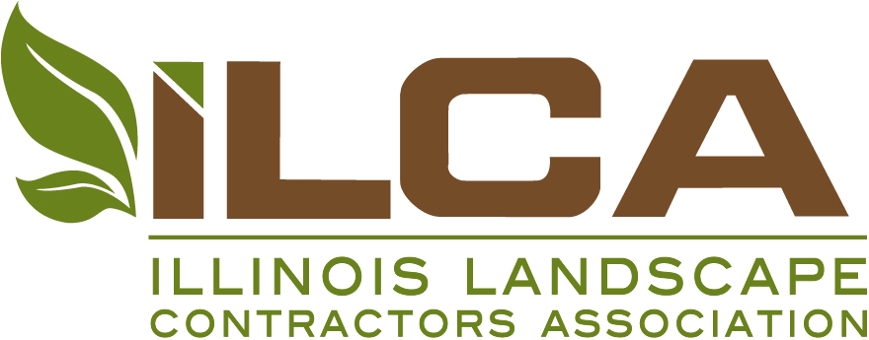

Name:
[ ] School: (check School/Home to indicate preferred correspondence address)
Address: _________________________________________________________
City:______________________ State/Province:__________ Zip: ____________
Country: ______________________________
Phone: ___________________Fax: ________________________
Email:_________________________________________________
[ ] Home:
Address: _________________________________________________________
City:______________________ State/Province:__________ Zip: ____________
Country: ______________________________
Phone: ___________________Fax: ________________________
Email:_________________________________________________

Signature:___________________________Date:________
The information contained within this application is to the best of my knowledge, truthful and valid. Any discrepancy may result in the removal of this application from consideration. I authorize ILCA staff to take any necessary steps to verify the claims made within.

Due Date: March 20, 2017

Illinois Landscape Contractors Association (ILCA)
Scholarship Program & Application

Read Before Proceeding with the Application
Five scholarships are available for 2017:
  - One $10,000 Scholarship
  - Three $5,000 Scholarships
  - One $2,500 Scholarship

Application Guidelines (Please Read Carefully)
Applicant must be:
- A resident of Illinois and enrolled full-time in an accredited two- or four-year college horticultural-related program, with course work toward a degree in a horticultural-related program. A horticultural-related program includes, but is not limited to, horticulture, environmental science, landscape architecture, botany, and agronomy.
OR
- A resident of Illinois and enrolled part-time in an accredited two- or four-year college horticultural-related program, who must be working towards a degree in a horticulture-related program. A horticultural-related program includes, but is not limited to, horticulture, environmental science, landscape architecture, botany, and agronomy.
The counselor or department head must stipulate you are working towards a degree in a horticulture-related program in his or her letter.
- Attending a school located in Illinois, Wisconsin, Michigan, Indiana, Missouri or Iowa. [A previous recipient may reapply – there is a limit of two scholarships.]
Application must include:
- Completed ILCA Scholarship Application
- A letter describing your goals and aspirations in the field of horticulture (not to exceed one 8½" x 11" page).
- A counselor or department head’s written evaluation of your classroom performance. For part time student applicants, the evaluation must stipulate the applicant is working towards a degree in a horticulture-related program.
- A transcript of grades and cumulative grade point average to date. Please indicate the grade point system used. In order to complete the application, send transcripts from the previous semester.
- Goals and work experience weigh heavily. Please attach evaluations/letters from employers, internship, work study, or any horticulture/landscape experience.
Submission Information and Judging
- Applications are due in the ILCA office no later than March 20, 2017. Mail to ILCA, The Scholarship Committee, 2625 Butterfield Road, Suite 104S, Oak Brook, Illinois 60523.
- A recipient may apply for a second scholarship; no more than two may be awarded to an individual.
- Applications will be anonymously judged. Award recipients will be notified about 45-60 days following submission.
Payment of Scholarships
- To receive payment, proof of enrollment for the following term must be submitted.
- Checks will be sent to the applicant upon receipt of proof of enrollment. The disbursement deadline is November 1st. A Scholarship Certificate will be awarded at ILCA’s Awards Program the following February.
- Please call ILCA with any questions at (630) 472-2851.
Please complete before proceeding | Check box
A. Yes, I have read and will abide by the above rules. I understand that failure to abide by these rules will remove my application from consideration.
I am (indicate below):
A resident of Illinois and enrolled full-time in an accredited two- or four-year college horticultural-related program, with course work toward a degree in a horticultural-related program. A horticultural-related program includes, but is not limited to, horticulture, environmental science, landscape architecture, botany, and agronomy.
 Two-Year Program  Four-Year Program

A resident of Illinois and enrolled part-time in an accredited two- or four-year college horticultural-related program, who must be working towards a degree in a horticulture-related program. A horticultural-related program includes, but is not limited to, horticulture, environmental science, landscape architecture, botany, and agronomy.
The counselor or department head must stipulate you are working towards a degree in a horticulture-related program in his or her letter.
 Two-Year Program  Four-Year Program

1. Year Graduated from High School ___________________

2. Anticipated Year of Graduation ___________
School:________________________________

3. Have you previously received a scholarship from ILCA? If yes, when_______________________________________
(No more than two awards will be made to an individual)

4. Horticulture courses taken that were of most interest (course name and number):

5. Describe your present interest in horticulture.

6. Experience in horticulture:

7. Check the following areas of interest:

❑
 Plants and their Use
❑
  Nursery Management
❑
  Equipment Operation and Care
❑
  Irrigation Management
❑
  Landscape Design/Build
❑
  Golf Course Management
❑
  Landscape Maintenance
❑
  Plant Biology
❑
  Garden Center Management
❑
  Soil Science
❑
  Computer Assisted Landscape Design
❑
  Interior Plantscaping
❑
  Research
❑
  Tree Care/Arboriculture
❑
  Other

Mail Completed Application Packet by March 20, 2017 to:
ILCA
The Scholarship Committee
2625 Butterfield Road, Suite 104S
Oak Brook, Illinois 60523
Questions: Call 630-472-2851 or email information@ilca.net

